**STEDMAN’S SPELLCHECKER INSTALLATION FOR MICROSFT WORD 365**

The Stedman's Spellchecker allows XMetal and Office 365 users to spellcheck scientific terms including the newest terms while working in the **XMetal** or **Microsoft Word 365**. The spellchecker is updated annually when new licenses are acquired. The current spellchecker is the **2021 version**.

Below are instructions on how to install Stedman's spellchecker for **Microsoft Word 365**.

**(Please note that this installation assumes that the user has elevated permissions (powerbroker). If not, please create a Service Now ticket to obtain elevated permissions.)**

The Installation files can be found in the following location on the L Drive

\\nciis-p401\Group03\OCPL\OCPL\_Cross\CDR\STEDMANS\Stedman2021_MU_Silent_Install_version

1. Open the installation folder

\\nciis-p401\Group03\OCPL\OCPL\_Cross\CDR\STEDMANS\Stedman2021_MU_Silent_Install_version 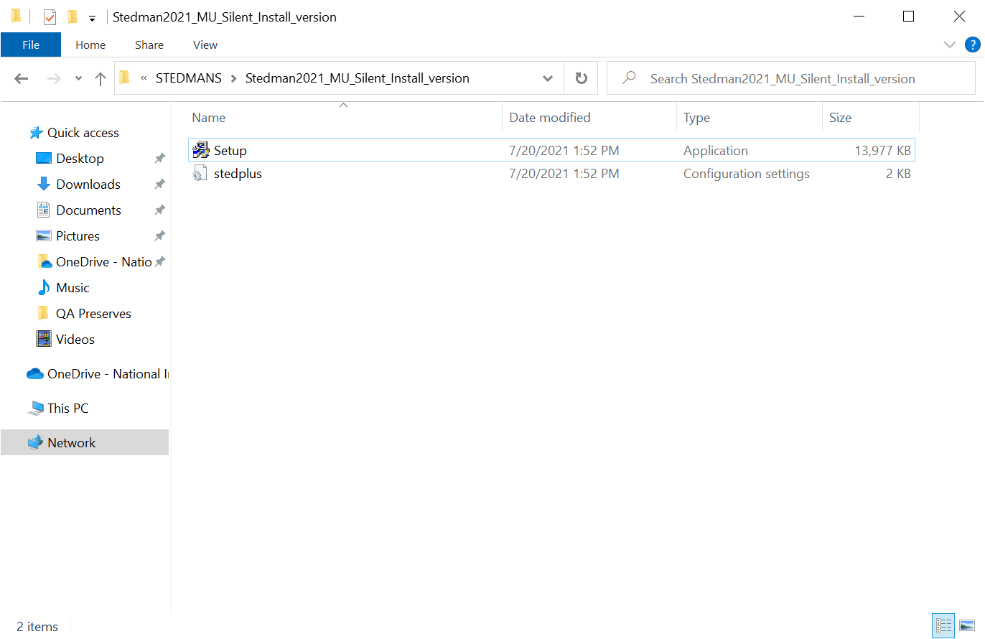

1. Right-Click on the Stetup.exe file and select **Run with Elevated Permissions**. If you don’t see this option when you right-click on the setup file, file a Service Now ticket to have a technician help you with the installation.

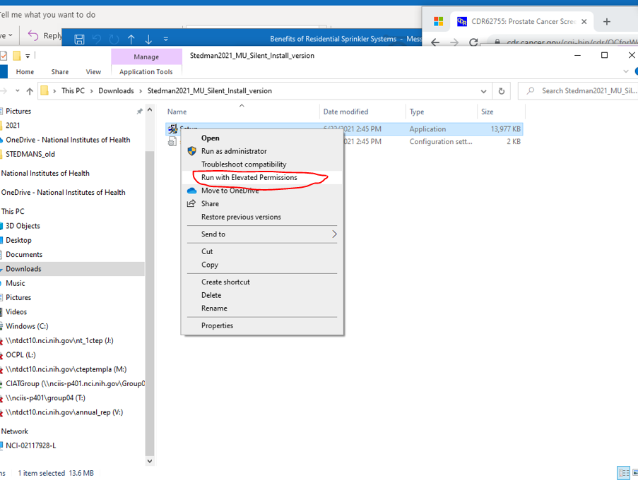

1. You will be presented with a new window to provide a password and justification.

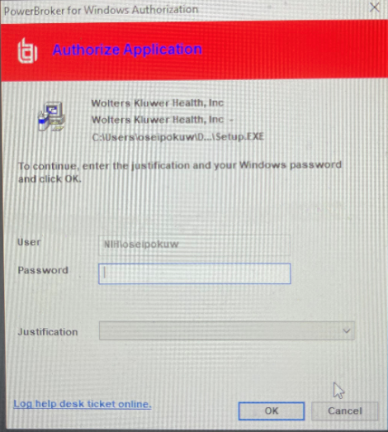

1. Type your normal network password and for justification, select “I need to run a work-related program.”, and click OK.

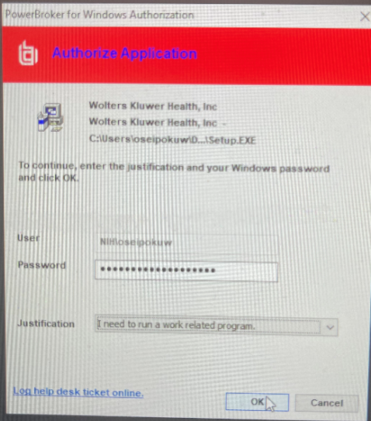

1. Click “Next”

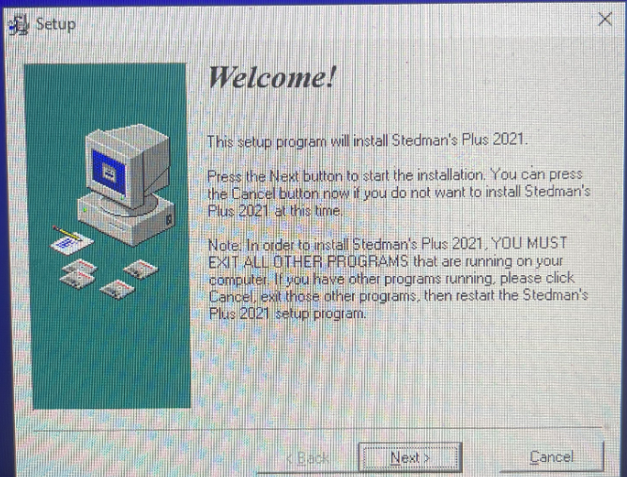

1. Accept the EULA

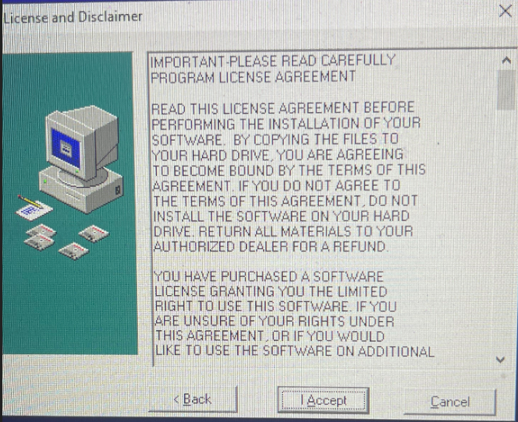

1. Select XMetal

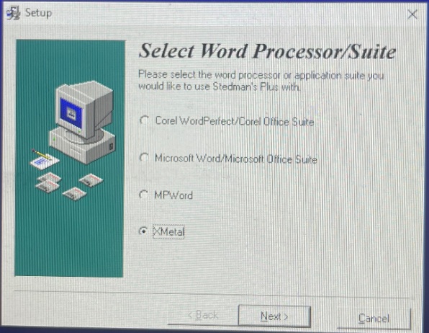

1. Select “Yes”

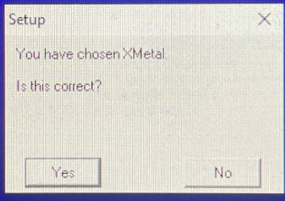

1. Select “XMetal 9.0”

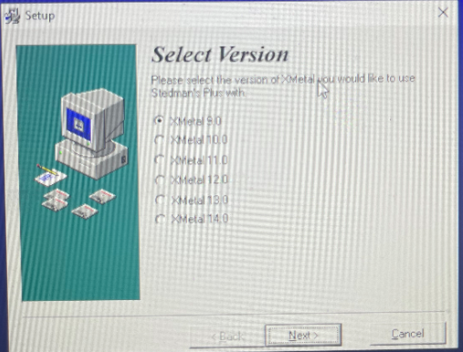

1. Select “Yes”

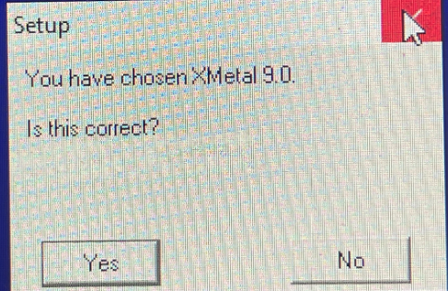

1. Select “Next”

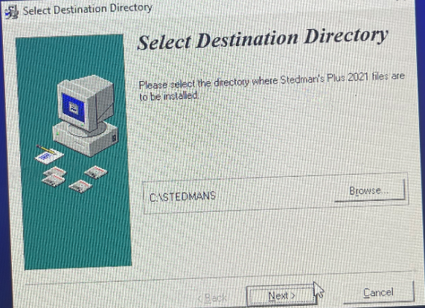

1. Click “Next”

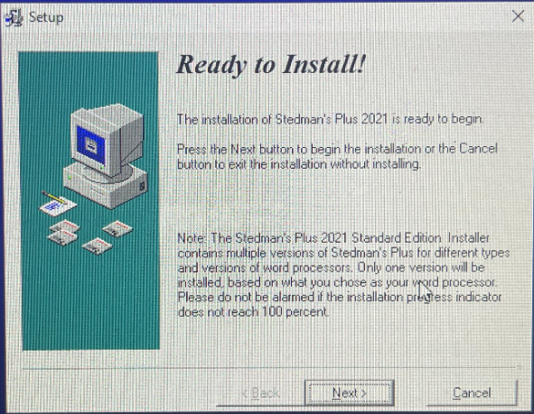

1. Click “No”

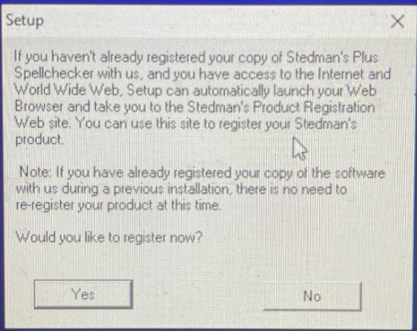

1. Click “No”

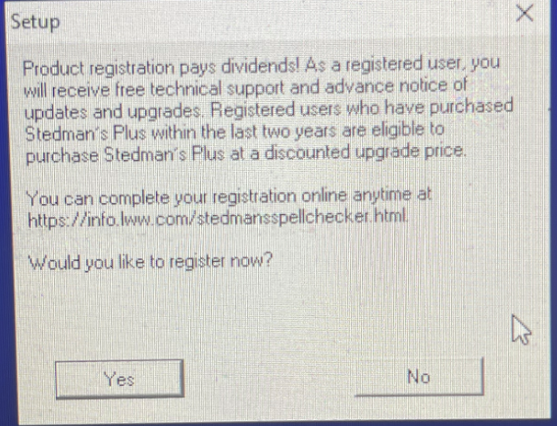

1. Click “Finish”

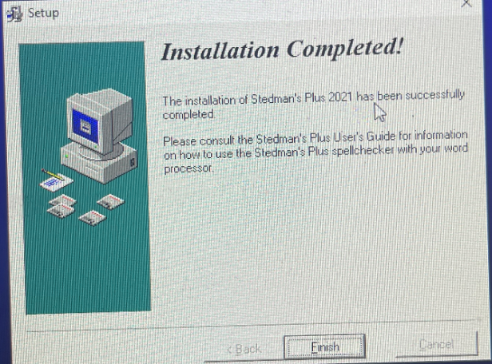

***2021 Test words:***

***Is It Really Working?*** You can use the words “remdesivir” and “Veklury” to make sure Stedman’s Plus 2021 has been installed properly. Simply type “remdesevir” and “Viklury” (incorrect versions of the above words) and spellcheck your document. Your spellchecker should highlight these words and will suggest the correct words “remdesivir” and “Veklury” from the Stedman’s Plus 2021 dictionary file.